Dublin Juvenile Cross Country Championships 2015
Map of Phoenix Park.
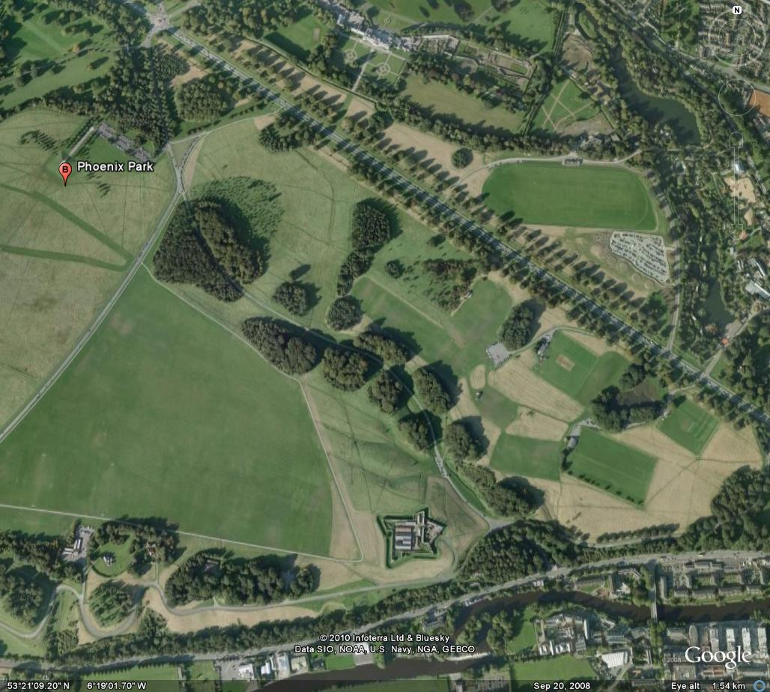
Papal Cross
Aras
Zoo
Magazine fort
Cross Country
Circuit’s in this area.
Main road

2000metre Lap – Sunday 19th Oct 2014
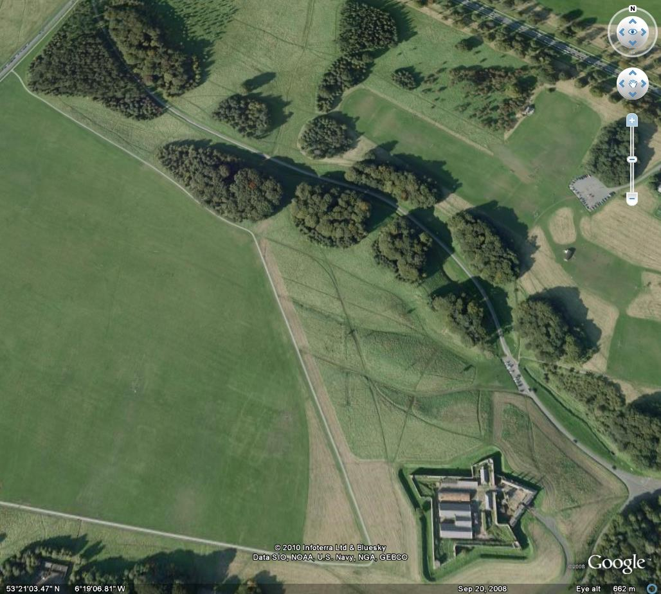
Start & Finish areas

900m start
2000metrec course
For all races
U10 Girls & Boys - 1K – small lap
U12 Girls & Boys – 2K – 1 x 2000m lap
U14 Girls & Boys – 3K – 1 x 2000m lap + 1 x 1000m lap
U16 Boys & U16 & U18 Girls – 4km 2x2000m lap
U18 Boys – 6K 3 x 2000m lap
AAI Autumn Open - Senior Ladies – 5km 2x2000m lap +1x1000 lap
Junior Ladies – 4K - 2x2000m lap
Junior Men - 6km 3x2000m lap
Senior Men - 8km 4x2000m lap

1000m Course Map

START /FINISH
All races

Finish Areas all races

900m start
1000m circuit green circuit

900m start

1000 metre lap

