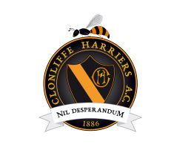

Women in Sport Week Clonliffe Harriers 800 club race
06/03/25

Start list

Race 1:
120 – Julie Larkin
121 – Niamh Ni Chuinn
122 – Jessica Laflamme
123 – Helina Butterly
124 – Lucy McFetridge
125 – Mya O’Reilly
126 – Sophie Kernan
127 – Rachel Ardiff
128 – Sarah Doherty
129 – Alanna Burke
130 – Aoife O’Reilly
131 – Katie Halpin
132 – Aisling Killea.

Race 2:
133 – Siobhan Mulvey
134 – Melissa Curran
135 – Maura Matthews
136 – Karen McAffe
137 – Siobhan McCarthy
138 – Anne Lyons
139 – Aisling Webb
140 – Rebecca Finn
141 – Jule Gauselmann
142 – Paige Elliott
143 – Mae Rose Mayson
144 – Harriet Kenny
145 – Hannah Walsh
146 – Aisling Andrews
147 – Catherine Harvey
148 – Sarah Owens
149 – Aisling Faherty

